**React Native Assignment**

**Task (1)**

Create custom components using Text Input for email and password with validations and hide show password functionality, which shown below.

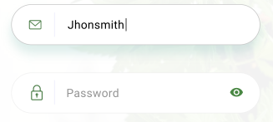

**Task (2)**

Implement the API using the redux tools-kit and bind API data with flatlist. Make sure the below format is used for listing the data using flatlist.

URL: <https://randomuser.me/api/?results=100&inc=name>

Title: Mr.

First: Mohit

Last: Shukla  
Full Name: Mr. Mohit Shukla

**Task (3)**

Push notifications using firebase for android & iOS platform.

**Task (4)**

Implement Drawer & Bottom Tab navigation functionality.

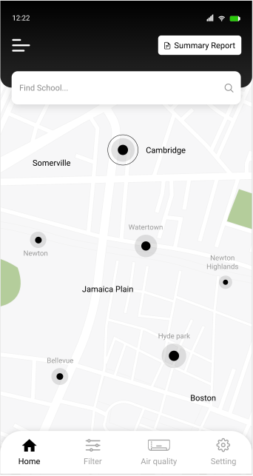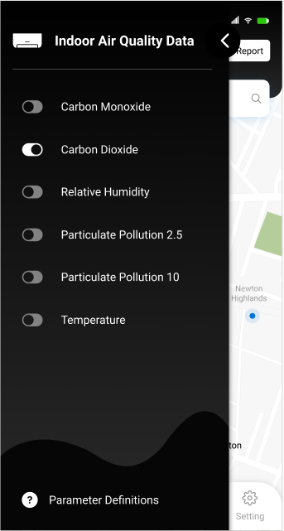

**Task (5)**

Countdown Mobile App.

Users enter a name for their countdown timer (e.g. My Wedding”), enter a date, and time for when the event will take place. Afterwards, users can view the countdown screen for an event, showing how many days and hours are left.

The UI should include:

* A countdown screen with a timer for the selected event
* A button to add a new countdown event
* A list of all active countdown events
* Allow users to customize the look and feel of each event (i.e. choose a color scheme, add an emoji, or upload custom background images)

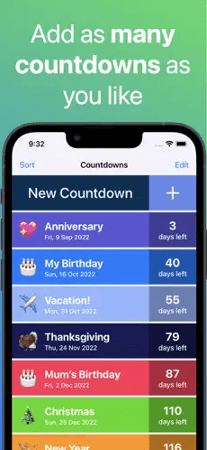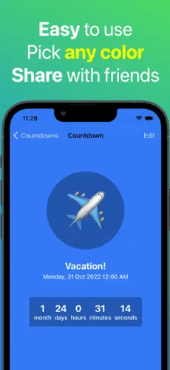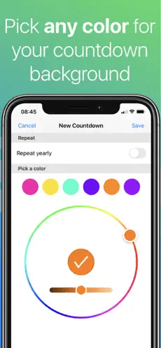

**Task (6)**

Implement the google map and apple map functionality and show the user current location.

**Task (7)**

Create a screen for registration form for visiting card details and using that details user will navigate to visiting card detail screen with sharing functionality. User can share the card via WhatsApp, Gmail etc.



**Task (8)**

Implement the login with google or Auth0.

**Task (9)**

Implement the login with Facebook.

**Task (10)**

Implement the login with Truecaller.